M A S T E R P L A N · M U L T I M O D A L U N D E R S T A N D I N G

Perception SLM
Small, from-scratch models that understand images, video, and audio — not generate them. On-device first, cloud second. Efficiency is the moat.
0.3–3B params
Image
Video
Audio
Not generation
HuggingFace-first data

01 The problem 02 Pros & cons 03 Architecture
- Components

- Tech stack

- System design

- Issues & optimization
- Datasets

- Roadmap

10 Repo & tests

S E C T I O N 0 1

The problem — what we solve
Understanding an image, video, or audio clip today means calling a giant cloud model. For a real product that means three hard problems: cost (pay per call),
latency + connectivity (round-trips, no offline), and privacy (user data leaves the device). Small on-device models remove all three at once.
Fig 1 · Cloud-only vs on-device perception
Our approach: on-device SLM
Device / camera / app

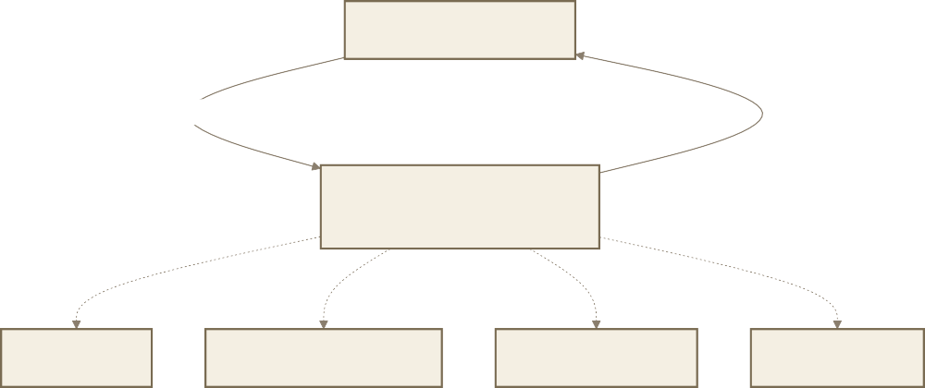
Cloud-only (today)

Device / camera / app
upload raw pixels and audio
answer
Big cloud modelGPT-4o / Gemini / Qwen-72B
pay per call
300-900 ms round-trip
data leaves device
needs internet
answer in ms

Small perception model0.3-3B, quantized, local

only heavy jobs
Optional cloud tier
works offline
data never leaves
ms latency
~free inference
S E C T I O N 0 2

Pros & cons
You don't win on model size — you win on proprietary task data and being the best at running tiny + on-device. Everything downstream optimizes for those two.

PROS
Cost moat — inference ~free vs per-call APIs
Privacy — data stays on device (health, finance)
Latency — ms → real-time video, robotics, AR
Defensible via data + efficiency, not scale
Field-proven: SmolVLM, Moondream, Whisper
From-scratch is realistic at small size

CONS / RISKS
3 modalities = 3 startups → focus needed
Data quality/labeling/licensing = 60% of work
Small models trade accuracy for size
Train compute real: 8–64 GPU-days / iteration
Big players ship free small models Reliability & eval are genuinely hard

Fig 2 · Decision map

Cost moat

Millisecond latency Data + efficiency moat

Privacy on device
Pros

Field proven

Perception SLM

Reliability and eval hard

Compute cost

Risks
Free models from big players
Accuracy vs size tradeoff Focus across 3 modalities

Data is 60% of work

S E C T I O N 0 3

Architecture — big picture
Three separate models, one shared core. Never force one backbone across pixels
+ frames + sound — it hurts quality. Share the decoder + tooling, not the encoders. What's genuinely from scratch is the connector (and optionally the decoder).
Fig 3 · Shared core + three models
SHARED PERCEPTION CORE (src/common)
defines interface
e
defines interface
Connector
Connector resampler
Connector

defines interfac
Audio encoderWhisper-style ~40-300M
Temporal moduleframe sample + token merge
Vision encoderSigLIP/ViT
~80-400M
IMAGE MODEL
Log-mel front-end
Reuses image encoder
AUDIO MODEL
VIDEO MODEL
Connector interfacefeature to token projector

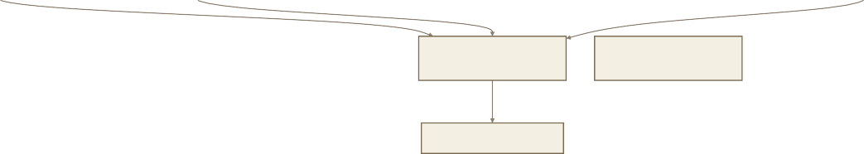
Small language decoder 0.3-1Bthe 'SLM'
Training / Eval / Data tooling
Text / labels / JSON answer
Tokenizer
S E C T I O N 0 4

Each component in depth

· Image model — data flow
Encoder ~80–400M params, 384–512px input, patch 14/16. From scratch via SigLIP contrastive pretrain, or start from open weights + finetune. Built first — its encoder is reused by video.
Fig 4 · Image — image + prompt → answer

Connector: MLP projector
ViT / SigLIP encodergrid of patch embeddings

Patchify 14/16px

Image 384-512px
Tokenizer
Text prompt

Concat [vision tokens | text tokens] |  | Decoder 0.3-1B |  | Answer / JSON

· Video model — the time dimension
This is where efficiency work concentrates: N frames × M patches explodes token count. Fix with frame subsampling, keyframe selection, token merging, and a resampler.
Fig 5 · Video — reuses image encoder + temporal module
Video clip
Frame sampling 1-8 fps+ keyframe selection
Image encoder sharedper-frame patch tokens
Token explosion heremerge ToMe / Q-Former resampler
Temporal transformermotion / events over time
Connector
Decoder
Video answer / caption / event

· Audio model — independent pipeline
Understanding, not just transcription: sound classes, emotion, intent, audio Q&A. Fully independent → can be built in parallel from day one.

Fig 6 · Audio — waveform → meaning

Prompt: transcribe / what sound / intent |  | Tokenizer

· Connector & training curriculum
Transcript / class / intent / QA

Decoder

Concat [audio tokens | text]
Connector
Conv stem +
TransformerWhisper-encoder style
Log-mel spectrogram 80 mels
VAD / segment
Waveform 16kHz
The connector maps encoder features into the decoder's token space — trained on our (modality, text) pairs. That's the defensible asset. Training runs as a staged curriculum.

Fig 7 · Connector design + 5-stage training

Encoder features

Design choice

simple LLaVA-style fewer tokens
MLP projectorkeeps all tokens
Q-Former / ResamplerK query tokens

Tokens in decoder space

1 Encoder pretrain: contrastive / SSL

4 Distillation + quant-aware int4/8
3 Instruction tuning: LoRA/QLoRA
2 Alignment: train
CONNECTOR only
5 Eval gate: golden sets + latency
S E C T I O N 0 5

Tech stack — offline / online / cloud
One training checkpoint produces two builds: a batched GPU server for the cloud tier, and a quantized single-file build for on-device. Never two codebases.
TRAINING (offline plane)
PyTorch 2.x
HF
Transformers/Datasets/Accelerate/PEFT
DeepSpeed / FSDP + FlashAttn2
W&B tracking
Hydra configs
ONLINE serving (cloud tier)
vLLM / TGI
FastAPI + Uvicorn
Redis + Celery queue
Docker + Kubernetes GPU autoscale
Fig 8 · Three planes — one checkpoint, two builds
one checkpoint
same checkpoint, quantized
OFFLINE / ON-DEVICE
TensorRT Jetson
ExecuTorch / TFLite Android
Core ML iOS/macOS
ONNX Runtime cross-platform
GGUF +
llama.cpp/whisper.cpp CPU

Quant int4/8: AWQ/GPTQ/GGUF

S E C T I O N 0 6
LAYER
OFFLINE / ON-DEVICE
ONLINE (CLOUD)
CLOUD INFRA
Runtime
GGUF, ONNX, Core ML,
ExecuTorch, TensorRT
vLLM / TGI
RunPod/Lambda →
AWS/GCP
Quantize
int4/int8 (AWQ, GPTQ, GGUF)
fp16 / int8
—
Storage
on-device file
—
S3 / GCS
Data
source
—
—
HuggingFace Hub
(streamed)
CI/CD
—
GitHub Actions →
test + build
Model registry (HF
private)

System design — deployment planes
Device-first, cloud-fallback. Data version + model version + eval report always travel together. Drift telemetry feeds back into retraining.
Fig 9 · End-to-end system with drift → retrain loop
ON-DEVICE (default path)
heavy job
API Gateway FastAPIauth, rate-limit
CLOUD (fallback / heavy / batch)
Client / devicecamera, phone, edge, app
Quantized runtimeONNX/GGUF/CoreML
- ms, private

Inference clustervLLM/TGI GPU pool, batched

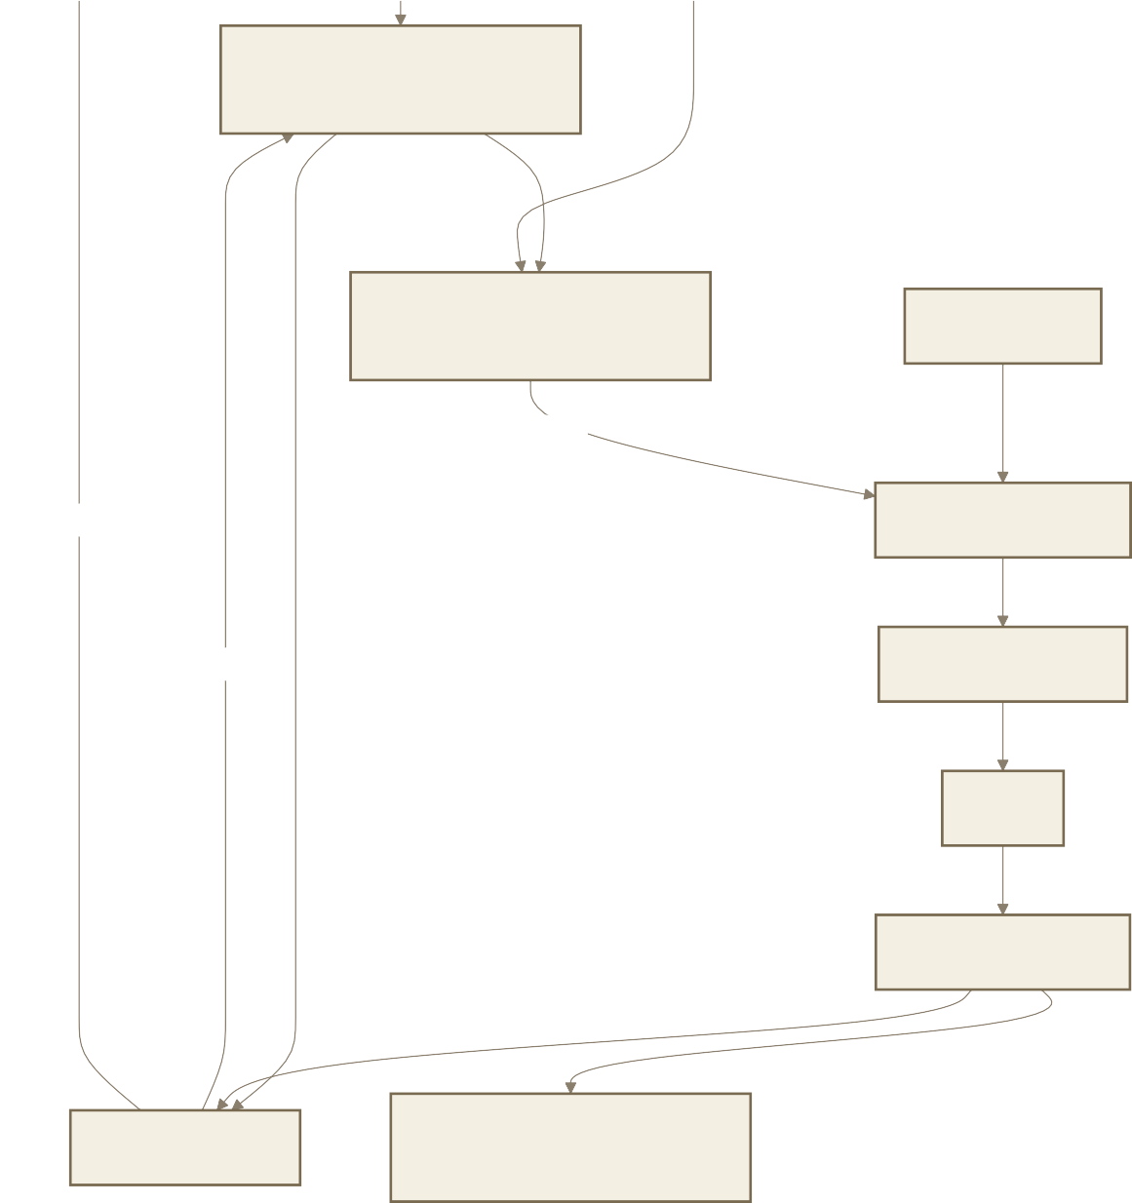
SHARED PLATFORM
Telemetry / W&Blatency, drift, eval
TRAINING PLANE

HF datasets

drift, retrain

push edge build Clean/label/shard

promote Train DeepSpeed

Eval

Quantize / export

Model Registry Object storage S3data + checkpoints

S E C T I O N 0 7

Issues & how we optimize
Fig 10 · Efficiency & Reliability toolboxes (ranked)
Reliability toolbox
Golden test sets

CI eval-gate: block on regression
Drift monitoring
Uncertainty / abstain
Shadow deploy before promote

Efficiency toolbox

Quantization int4/8

Distillation teacher to small

Pruning
Token reduction video

Graph fusion, static shapes, KV-cache

PROBLEM SYMPTOM FIX

Video token explosion
OOM, slow frame subsample, keyframe, token merge (ToMe),
resampler

Quantization accuracy drop
int4 gets dumb quant-aware training, mixed 4/8-bit, per-channel,
keep sensitive layers high-precision

Hallucination invents unseen text
grounding loss, hard negatives, abstain training, constrained/JSON decode

Small model underfits
mediocre everywhere
distillation from big teacher, curriculum (easy→hard)

Data noise unstable training dedup, CLIP-score filter, consensus labels, clean
held-out set

Field drift demo works, field fails
collect field data, drift telemetry, periodic retrain

Weak-HW latency too slow on
phone
distill smaller, ONNX graph opt, fusion, static shapes

Audio robustness fails on noise/accents
SpecAugment, diverse data, VAD front-end

S E C T I O N 0 8

Datasets — HuggingFace-first
Stream from the Hub (don't fully download), clean and filter, shard, version, and freeze a held-out eval split per version. Always verify licenses before commercial use.

Fig 11 · Data pipeline
stream Clean & filterdedup, CLIP-score, language
MODALITY
PRETRAIN / ALIGN
INSTRUCTION / TASK
Image
LAION subsets, COCO Captions,
CC3M/CC12M, SBU, DataComp
LLaVA-Instruct, VQAv2, GQA, TextVQA,
DocVQA, OCR-VQA, ChartQA, AI2D, FUNSD
Video
WebVid, HowTo100M
MSR-VTT, ActivityNet-Captions, NExT-QA,
VATEX, Something-Something-v2, Ego4D
Audio
LibriSpeech, Common Voice, GigaSpeech, VoxPopuli, People's
Speech
AudioSet, ESC-50, FSD50K, UrbanSound8K,
AudioCaps, Clotho, WavCaps
HuggingFace Hub

Training + eval

Freeze held-out eval split

Version: dataset card + hash
Shard to WebDataset/Parquet on S3
S E C T I O N 0 9
Roadmap — install → deploy
Audio is independent → start in parallel immediately. Video needs the image encoder → build Image first (fast) so Video reuses it. You still get audio + video early.
Setup
P0 env + toy smoke test
P1 reproduce tiny VLM
Fig 12 · Timeline (weeks)
Perception SLM roadmap (weeks)
P2 IMAGE model v0 (first)
Models
P3 AUDIO model v0 (parallel)
P4 VIDEO model v0 (reuses img) P5 serving online+offline
Ship
P6 optimize + harden
P7 deploy cloud + edge SDK
W0 W0 W1 W1 W2 W2 W3 W3 W4 W4 W5 W5 W6
Fig 13 · Phase gates — must pass to advance

P0 toy trains+evals end-to-end |  | P2 image runs offline, beats baseline |  | P3 audio transcribes + answers, quantized |  | P4 video hits latency target |  | P5 one checkpoint serves online + edge |  | P7 shadow-tested, promoted, SDK shipped

S E C T I O N 1 0

Repo & test structure
Every functional section has its own source folder and a mirrored test folder ( test_<name> ). Tests are first-class — reliability is the product.
CI on every PR
pass
Unit: shapes, forward
Integration: tiny data to eval
Eval-gate
regress
Fig 14 · src ↔ tests mirror + CI test tiers
src/
common
serving/offline
tests/ (mirror)
img_video_audio/
├── MASTER_PLAN.md · README.md · requirements.txt · .gitignore
├── configs/ # Hydra/YAML per model & experiment
├── data/{raw, processed, pipelines}
├── src/
│
│
│
│
├── common/
# tokenizer, connector, decoder, utils
├── image_model/ video_model/ audio_model/
├── training/ eval/
└── serving/{online, offline}
├── tests/test_{common,data_pipeline,image_model,video_model,
│ audio_model,training,eval,serving_online,serving_offline}/
├── deploy/{docker, cloud, edge}
├── notebooks/ scripts/
test_serving_offline
test_serving_online
test_eval
test_training
test_audio_model
test_video_model
test_image_model
test_common
serving/online
eval
training
audio_model
video_model
image_model
block merge
merge allowed

Next: scaffold starter code for src/common + src/image_model (encoder→connector→decoder skeleton + tests), then Phase 0 — environment + toy end-to-end smoke test.

